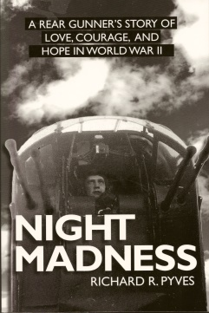
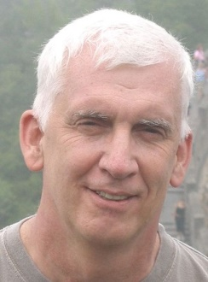
Upon early retirement in 2006, I decided that it was important to keep mentally active so I decided to devote my energies and time to writing. From the start, my particular interest was in historical non-fiction with each story having a direct linkage to my family. I once heard that as a writer, it is an advantage to write from your own particular field of experience so writing about family can be an ideal topic as long as your story is compelling and can appeal to a broad audience.
Rick Pyves – Published Author, Historian & Genealogist
My first book, Night Madness: A Rear Gunner’s Story of Love, Courage, and Hope in World War II, was published by Red Deer Press in October 2012. Based on interviews, painstaking archival research, and letters from a long-distance love affair, captured in daily correspondence, I was able to weave together my father’s tale into a touching love story and one man’s very personal war.

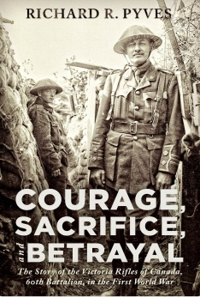
My latest published book, Courage, Sacrifice, and Betrayal: The Story of the Victoria Rifles of Canada – 60th Battalion in the First World War was released in March 2018 by Helion & Company Limited in the UK and by ECW Press in Canada. Courage, Sacrifice, and Betrayal provides a detailed account of the day-to-day operations of the 60th Battalion and the lives of its many soldiers including A.Y. Jackson, future Group of Seven Artist and my grandfather, Sergeant Edward Pyves (Military Medal).

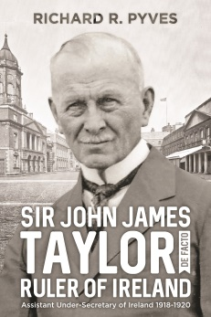
I have just completed my trilogy and I am now looking for a publisher for my story about my maternal, great-grandmother’s brother, Sir John James Taylor, Assistant Under-Secretary for Ireland, who was the de facto ruler of Ireland from 1918 to early 1920. It is the story of a commoner, born in India who joins the British Civil Service as a young teenager and rises through the ranks to a position of influence during the Irish War of Independence.

Most recently I have started research for my fourth book about my maternal grandfather, Bartholomew Eason who was by day a chauffeur and at night a professional singer, comedian and master of ceremonies who participated in over 250 shows in Montreal in the 1920s through the 1940s, in support of local charities and the unemployed during the great depression.

