



- Editorial: Premier Ford sent me money…attached strings not visible!
- City Desk - City of Pickering: Mayor and councillors
- Books - what I read and review
- Computers: sites, apps, plus
- Writers: stuff for writers
- Fun: just fun stuff
- Money: advertising and promotion
- You deserve a break: it is what it is!
- Letters and comments: your say!
- Upcoming Events: plan ahead

The Editorial:

Money from Queen’s Park is of questionable value
The Government of Ontario recently sent me money: a license renewal refund of nearly $500. I find this refund very troubling even as I am reminded of the phrase, “Never look a gift horse in the mouth.” Being given money is not at question. What is worrisome is all the implications behind the provincial ‘gift.’ Very worrisome.
No one complains about receiving money and receiving money from the government should be even more gratifying. However, this financial gift carries a burdensome load of anxiety with it. Strings may be overlooked as one basks in the warmth a money gift but the consequences and implications need consideration.
Just consider:
- How is the provincial government paying for all these refunds?
- How does this refund impact on the provincial debt load?
- Aren’t non-driving residents of the province subsidizing the licensed drivers?
- How is the government planning to offset the increased provincial debt these refunds incur?
It doesn’t take rocket science to do the math: money give away? Election coming. Another example of this kind of ‘electioneering’ is the $10/day child care policy negotiated recently with Ottawa. That policy has been on the table for many months, if not years. Other provinces boarded that gravy train while the Harlequin ham at Queen’s Park merely sat at the table. An election is at hand. Primo Queen’s Park pagliaccio signs a deal. Interesting! Again, doesn’t the province incur some kind of added debt even with federal funding? Perhaps the whole picture is just a little out of focus here: Ottawa is picking up the whole tab for child care across the entire country out of caring for the general populace? Somehow that picture is just a bit out of focus when one considers how the incurred debt will be handled.

Premier Ford and Trudeau are perfect examples of ‘well worn governments being ready to be turfed.’ Trudeau wants the voters to see him as a leader who can compromise and negotiate improvements to national policy. But with three election victories under his belt, perhaps it’s time for a new captain at the helm. As for Ford, who knows what he is trying to do. He is scrambling as the writing on the wall becomes increasingly clear. Is this leader of the provincial government up to the job as he reinforces this day after day? He began his term will strong pandemic strategies. Then he began seeing himself as more knowledgeable than the medical/scientific experts at which point he began vacillating and supplanting the advice of experts with his own ‘expertise.’ Remove the masks, replace them; loosen restrictions for businesses, tighten them again. Government by how the wind blows or what the polls show. Political competency a la Ford. Classic!
Government policies should be based on principles, values, and ethical foundations not referendum and polled consensus. The public has its say every election, not every day, or week. This government confirms its lack of principled foundation, ethical base.
Denigration and criticism of government is not the primary objective here. The goal is to remind voters that government policies need examination and review. All that glitters is not gold. What may seem like beneficence at prima fascia may have a dark side seen more clearly only with deeper examination and consideration. Economically, the people of Canada are facing challenging times. Inflation and prices are hitting thirty-year highs. Government ‘gifts’ need to be examined with a judicious eye, something that is increasingly difficult to do when one is already living close to the line, hard pressed by personal budgeting, struggling to earn a living and survive. Receiving these government handouts looks good at first examination. Many of us cannot give them a pass. Closer examination may reveal that we will end up paying more than we have received.
Maybe it’s time to look the gift horse in the mouth!
[Views expressed here are solely those of the publisher and are not necessarily those of any others in this newsletter.]

City Desk



Hello everyone,

“On March 24th, I provided the business leaders of our community an update on all of the exciting projects and initiatives taking place in Pickering during my annual Ajax-Pickering Board of Trade address.

Here are some highlights:
- The City partnered with William F. White to bring Canada’s largest movie and television back lot to Pickering. This partnership will enhance job creation, generate economic spin-off for local businesses, provide training opportunities to students, and generate approximately $3.5 M in non-tax revenue for the City. Watch the back lot come to life on-screen in Amazon Prime Video’s new hit series, Jack Reacher.
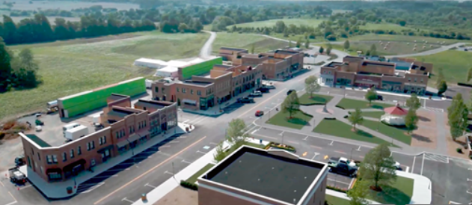
- Pickering Casino Resort is open and one of the best-performing casinos in the country. As part of its revenue sharing agreement with OLG, Pickering has received approximately $5.4M in non-tax gaming revenue, most of which will be re-invested back into the community by funding a number of important capital projects.


- FGF Brands (the largest producer of fresh/artisan breads and sweet goods in North America) will be bringing thousands of jobs to Pickering as it acquires 149 acres in our Innovation Corridor to create a manufacturing campus. Some of its well-known brands include Wonder Bread, ACE Bakery, Casa Mendosa, and Country Harvest.

- Hi Tech Bay, an IT parts manufacturer and distributor, will be relocating and expanding its operations from Toronto to Pickering. Hi Tech Bay’s corporate partners include Microsoft, Best Buy, Walmart, Amazon, and eBay. This addition will create hundreds of high-tech and skilled jobs for our residents.


These are just a few of the many incredible projects we’ve been working on here in Pickering.

Finally, I’m both happy and relieved to announce that on March 28th at 9 am, the City of Pickering terminated its State of Emergency Order related to the COVID-19 pandemic. Thanks to the collective efforts of our residents, businesses, community groups, front-line workers, and health care heroes; we were able to mitigate the spread of COVID-19 and do our part to protect each other as well as our health care system.

We look forward to regaining a sense of normalcy and seeing everyone in-person once again!”
Mayor Dave Ryan

Councillor Christine Doody-Hamilton writes…

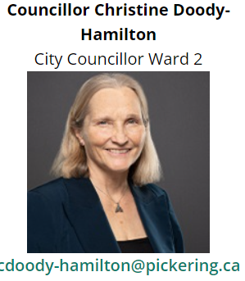

Hello everyone,

I am into my third month as City Councillor for Ward 2, and the pace is not slowing down! Our big accomplishment for March was the approval of the City budget for 2022.
This was a good news budget in many ways: first, the tax increase was limited to 1.79%. This is the lowest tax increase of any municipality in Durham Region! We did it, while still providing the high level of service you’ve come to expect from the City!
Lots of great work happening in Ward 2 in 2022:
- Fairview Avenue reconstruction
- asphalt resurfacing of Rawlings Drive, Haller Avenue, and Lublin Avenue
- Tennis court resurfacing at Bayridges Kinsmen Park and
- park upgrades for accessibility at Forestview Park and Frenchman’s Bay Progress Park

The Sandy Beach Road reconstruction will begin this year, and the Beachfront Park – Master Plan Detailed Design study will be underway shortly.
One of the budget items I’m most pleased with is the increase to the property tax rebate for low-income seniors. It was $425 last year; it is $525 this year. Every little bit helps to make our seniors feel more comfortable in their own homes.
Should you want more information on this program, please email me at:
cdoody-hamilton@pickering.ca .
And finally, Spring is in the air! Despite the unseasonably cold temperatures, the massive snow piles have finally melted, and there is some warmth in the sunshine.
My daughter and I are already planning our Spring garden. If the weather continues to improve, we will start planting our spring crop in the next few weeks: Romaine lettuce, spinach, peas, radishes and Walking Egyptian onions. Yum Yum! Nothing tastes better than fresh vegetables harvested from your own garden…good for the body, and good for the soul!
Sincerely,
Councillor Christine

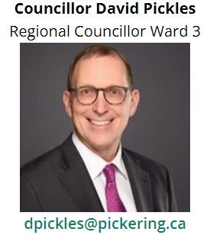

Hello everyone,
Thoughts about Ukraine
 
It is horrific and tragic to see the death and destruction caused by the invasion of Ukraine by Russia. I am not an expert on the geopolitics and history of the area, but I understand that the Russian and Ukrainian peoples and their territories have had close links pre and post the Soviet era leading up to Ukraine's independence in the 1990's. At the city we have raised the Ukrainian flag and passed motions supporting the Ukrainian peoples and their independent nation and calling for the withdrawal of Russian forces and establishment of peaceful coexistence. The support from our community has been great and I know the Ukrainian community, Royal Canadian Legion, the city, and many residents and other organizations have raised donations for Ukraine. Although as a municipality we don't have a role in Canada's Foreign Affairs we have called for Canada to do all it can. In addition to the personal toll of this invasion, I put on my municipal leader hat and I see that even when peace comes, hopefully soon, there is massive loss of infrastructure, including homes, schools, hospitals, roads, bridges, that will take years and years and billions of dollars to replace and rebuild. It is an overwhelming task that will take a Marshal Plan type response, like that following the Second World War, to address. Tragically, a senseless, brutal, devastating impact on Ukrainians. Our hearts go out to them.

What I am reading
 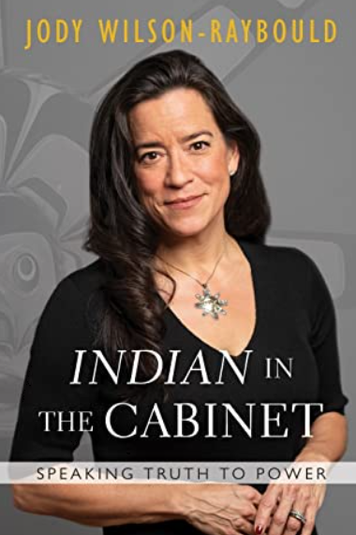
My reading habits always include a big pile of budget and council documents but currently my reading entails two biographies: Freddie Mercury (lead singer for Queen) and Jody Wilson-Raybould. I have just finished Freddie Mercury - The Definitive Biography and I am about to start Jody's Indian in the Cabinet. I expect they are going to be very very different! Freddie Mercury's tells his life story of a mega star and the expected wild rock and roll lifestyle not for the faint of heart but also of a man unsure of himself and his relationships that perhaps adds credence to the expression it’s lonely at the top. As a fan of Queen music I found it a great read. Jody as you may recall was the Attorney General of Canada and prominent in the news during the SNC-Lavalin affair. While I was employed with the provincial Ontario government I worked in the Ontario Ministry of the Attorney General and in Indigenous Affairs. So I look forward to reading about her life story and experiences in the federal government. After that, it will be time for some historical fiction and thrillers.

Sincerely,
Councillor Dave

 | BOOKz:
Stuart Woods
Woods is my favourite ‘escapism’ author. He writes ‘adult comic books’ that are perfect no brainer reading. Ideal for reading while sitting on the beach, on the back porch, or in the shade of a backyard tree. Light, laughable and lively, Woods loves to show off his hobbies, his favourite restaurants in NYC and his most enjoyed libations.
So if you want a book that just lets you sit back and be entertained a la TV like mode, Woods is your author.

Jody Wilson-Raybould: "Indian" in the Cabinet: Speaking Truth to Power
Just started reading this book and my first impressions are this politician-author is writing with sincerity and honesty. She seems to be quite put off by Trudeau Junior, and maybe justifiably so as she may have been railroaded out of cabinet by taking an ethical stand against a political one.
The book also seems to praise Indigenous ethical values and principles not just as being praiseworthy but also as ones all politicians should review and consider for incorporation into the political lives. …. More next month.

 | Computer Stuff

 | Notezilla  Use a computer a lot? Archive a lot of material? Save many files somewhere on your computer? Then you should be using Notezilla, an electronic sticky notes application that will have you keeping records is a very manageable and practical way. Read our full review at notezilla

 | Writers’ Stuff

Congratulations to Writer associate, Rick Pyves…

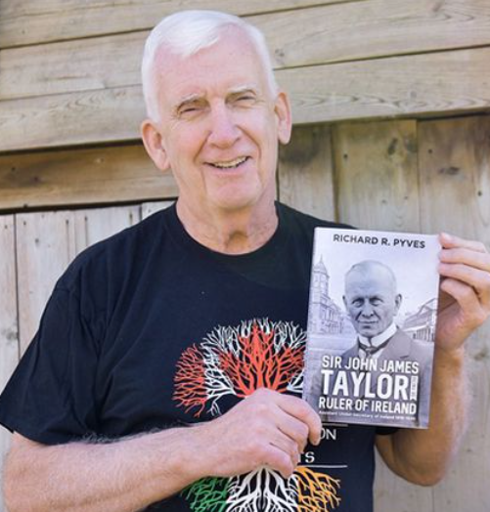 | Rick Pyves’ “great-grand uncle” was the Ruler of Ireland. Read the full article at PYVES

 | FUN STUFF

FREERICE: | Learn, Play and Give Back with Freerice!  Freerice is an educational trivia game that helps you get smarter while making a difference for people around the world. Every question you answer correctly raises 10 grains of rice for the World Food Programme (WFP) to support its work saving and changing lives around the world.  Private sponsors match the rice grain donations generated within Freerice, triggering a financial payment to WFP. This money goes into the pot of "greatest needs" to support the organization's ongoing emergencies. 100% of all funds generated via Freerice go to the World Food Programme. Freerice does not earn or keep any money it raises.  Since 2010, Freerice has raised more than 214 billion grains of rice for people in need. In cash equivalent, that is US $1.5 million! Join our global community and start making a difference today.  Thanks Ginger K

ACROSTIC:  The scrambled clues are all connected in meaning to a hidden acrostic word. Unscramble them to discover what’s in the bolded column.  1. EVRVE  2. GOURVI  3. CITAVIVY  4. PIAZZZZ  5. LVLNESSEI  6. NGZI  7. TEZS  8. ANBUOYCY | 

Source: Readers Digest

WORD POWER:
They say a picture is worth a thousand words. This quiz is about words dealing with photography. How many do you know?

WORD POWER
1. Bokeh effect creating:–
A: shadow.
B. blurred background.
C: high contrast.
2. Catchlight:–
A: light reflected in a person's eye in a photo.
B: light panel used in photography.
C: 19th-century term for flash.
3. Lookbook:–
A: camera shaped like a paperback novel.
B: viewfinder.
C: set of photos showing a designer's collection.
4. Daguerreotype:–
A: early photograph produced on a copper plate.
B: hyper-realistic painting.
C: date stamp on photos.
5. Vignette:–
A: photo negative.
B: photo made to appear older through costumes and sets.
C: portrait with darkened corners.
6. Aperture:–
A: film sensitivity to light.
B: space through which light passes.
C: appetite for photography.
7. Noise:–
A: visual distortion in a photo.
B: items cluttering an image.
C: celebrated school of abstract photography.
8. Resolution:–
A: staged photo.
B: final image in a series.
C: measure of the sharpness of an image.
9. Pixel:–
A: smallest unit of digital information in a photo.
B: tripod stand.
C: miniature camera.
10. golden hour:–
A: hour when the sun is highest in sky.
B: midnight during harvest moon.
C: period just after sunrise or before sunset.
11. aspect ratio:–
A: relative size of the subject in a photo.
B: distance between the photographer and the subject.
C: ratio of the width to the height of an image.
12. Sepia:–
A: reddish-brown colour.
B: image bleed between frames.
C: type of underwater photography.
13. Panorama:–
A: prism photography.
B: photo containing a wide view.
C: negative reaction to a photo.
14. camera shy:–
A: related to the time before photography.
B: disliking having one's photo taken.
C: nervous to take photos.
15. Photobomb:–
A: high-intensity flash.
B: move into the frame of a photograph as a prank.
C: bad photo.
Source: Readers Digest

ANSWERS: 1B,2A,3C,4A,5C,6B,7A,8C,9A,10C,11C,12A,13B,14B,15B

 | Money Stuff

 | Publishing all this stuff costs money…  So we look for donations and ask you to  visit “Our Supporters Page” at Supporters
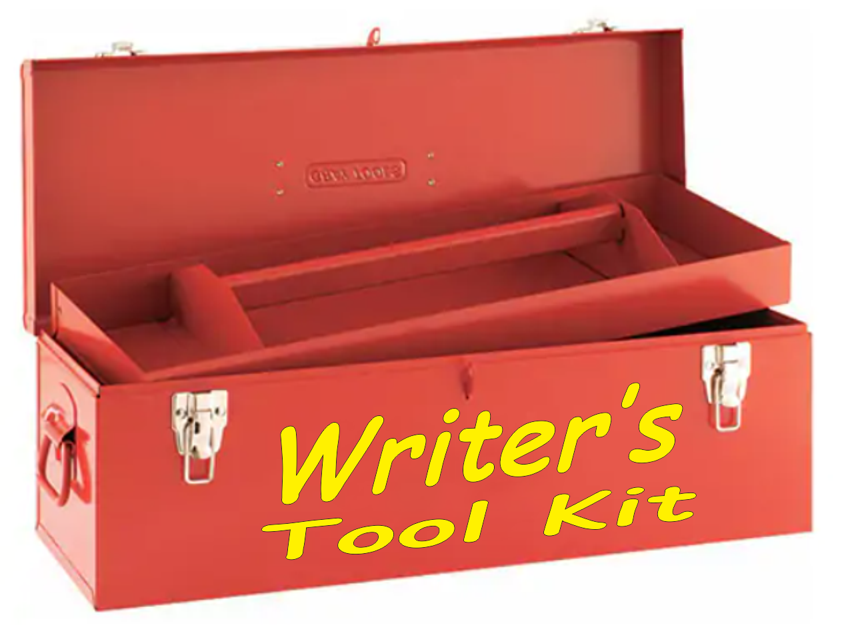 | Writers Tool kit  Every writer should have a tool kit.  We offer you access at our  “Writers Kit” at WRITERS_TOOL_KIT
 | “WILL-mate”  A few years ago when my mother-in-law passed away, this “WILL-MATE” (ESTATE ORGANIZER) was a Godsend. All the contact information, the needed professionals, the essential services and the ‘must-d0’ list were all in one place, easy to access, convenient to use and a tremendously useful assistance. Get more information about the “WILL-mate” (Estate Organizer) at Estate_Organizer

 | Ya need a break…  so here’s a bit of a distraction for you!

Way to go Jann Arden
 | Click to view, worth it> A great rendition

Grandma’s apron
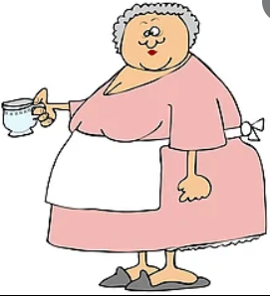

Did you ever make an apron in Home Ec? Do you even know the meaning of “Home Ec?” If we have to explain "Home Ec" you may as well just delete this.
Otherwise, read on.
The History of 'APRONS'
I don't think kids today know what an apron is.
The principal use of Grandma's apron was to protect the dress underneath because she only had a few and because it was easier to wash aprons than dresses and aprons required less material. But along with that…
An apron had many uses:
- It served as a potholder for removing hot pans from the oven.
- It was wonderful for drying children's tears, and on occasion was even used for cleaning out dirty ears.
- It was chicken coop tool used for carrying eggs, fussy chicks, and sometimes half-hatched eggs to be finished in the warming oven.
- It was ideal hiding places for shy kids.
- It warmed Grandma when the weather was cold, wrapped around her arms.
- It wiped many a perspiring brow, bent over the hot wood stove.
- It helped carry chips and kindling wood into the kitchen.
- It carried all kinds of vegetables from the garden.
- It carried out the hulls after the peas had been shelled.
- It was used to bring in apples that had fallen from the trees in autumn.
- It dusted furniture when unexpected company came into the driveway.
- It signaled that dinner was ready when Grandma walked out onto the porch, waved it.
It will be a long time before someone invents something that will replace that 'old-time apron' that served so many purposes.
Send this to those who would know (and love) the story about Grandma's aprons.
REMEMBER:
Grandma used to set her hot baked apple pies on the window sill to cool. Her granddaughters set theirs on the window sill to thaw.
The Government would go crazy now trying to figure out how many germs were on that apron.
I don't think I ever caught anything from an apron - but love...
Thanks Reg R.

What do you see?



How many images do you see?

- A detective holding binoculars?
- A letter “A”?
- A highway, roadway?
- A profile of a car?
- A full face of someone using binoculars?

Are the discs stationary or rotating?



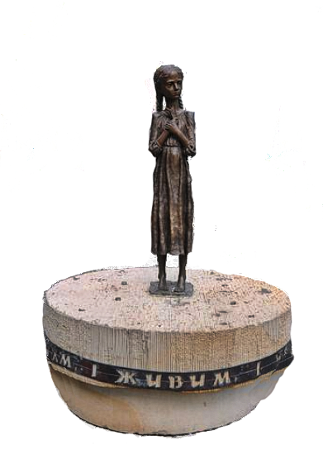 | Holodomor  After the end of the First World War, Ukraine was an independent state, but in 1919 the Soviet Union "sucked" it into the community of Soviet states. The Ukrainians considered themselves a Central European country, like Poland, and not an Eastern European country like Russia. They tried to restore Ukraine's independence.  In 1932, not wanting to lose control of Europe's main source of grain, Stalin took away the grain-producing land from the Ukrainian peasants and also all the grain, creating an artificial famine. The goal was to "teach Ukrainians to be smart" so that they would no longer oppose Moscow. The people who produced the most grain in Europe were left without a crumb of bread.  The peak of the Holodomor was in the spring of 1933. In Ukraine at that time, 17 people died of hunger every minute, more than 1,000 every hour, and almost 24,500 every day! People were literally starving to death in the streets.  Stalin settled Russians into the emptied Ukrainian villages. During the next census, there was a huge shortage of population. Therefore, the Soviet government annulled the census, destroyed the census documents, and the census takers were shot or sent to the gulag, in order to hide the truth.  Today, 28 countries around the world present the Holodomor as genocide against Ukrainians. You couldn't learn about it in school because almost all evidence was destroyed and victims were covered up for decades. To this day mass graves are being uncovered.  The Holodomor at that time broke the Ukrainian resistance, but it made the desire for Ukraine's independence from Russia eternal.  To view Ukraine before Putin, click > Ukraine before Putin

LETTERS and COMMENTS

Free speech is a right but it one must be cautious with it. Criticizing and attacking government leaders might be better left to other media. On the other hand, criticizing political leaders has its merit in that it may prod them into accountability but again does it deserve a place in this entertaining newsletter?
N.G.

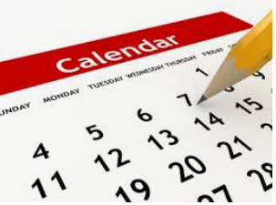 | Upcoming events

Apr 3 - Apr 9 National Library Week (USA) - theme: “Connect with your library”

Stay healthy, save and wear your mask.
Best,


and the “Boss”

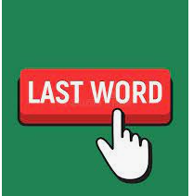
Be sure to visit our website at: www.szpin.ca


